AIBU -

Functionality
An asset that you produce in-house has two stages in its life that are relevant for accounting from the point of view of your company:
- Under construction phase
- Useful life (on commissioning of the asset)

Balance sheet should disclose the different phases of the asset. Therefore, it is necessary to manage the asset as a separate object or asset master record during the construction phase. The activity that records the change from phase 1 to phase 2 is called "capitalization of the asset under construction" . The asset under construction (AuC) can be managed in the system in two different ways, depending on the types of functions that you need. The AuC can be either a normal asset record, or a master record with line item management. Before an asset can be “settled” to another asset / object, a distribution rule is assigned to the asset master record.

Scenario
The transfer from the asset under construction to completed fixed assets can be handled in one of two ways:
Summary transfer from a normal asset master record to the receiver assets (transaction type 348/349)
Line item settlement of an asset under construction that has line item management. (Illustrated here)

Requirements
Asset master records with respective properties should exist.
AuC with Line management is required for using the transactions of distribution of line items and settlement.

Menu Path | Accounting → Financial Accounting → Fixed Assets → Posting → Capitalize Asset Under Construction → AIBU - Settle
Transaction Code | AIBU

1. Double Click on AIBU - Settle

AuC Settlement: Initial Screen

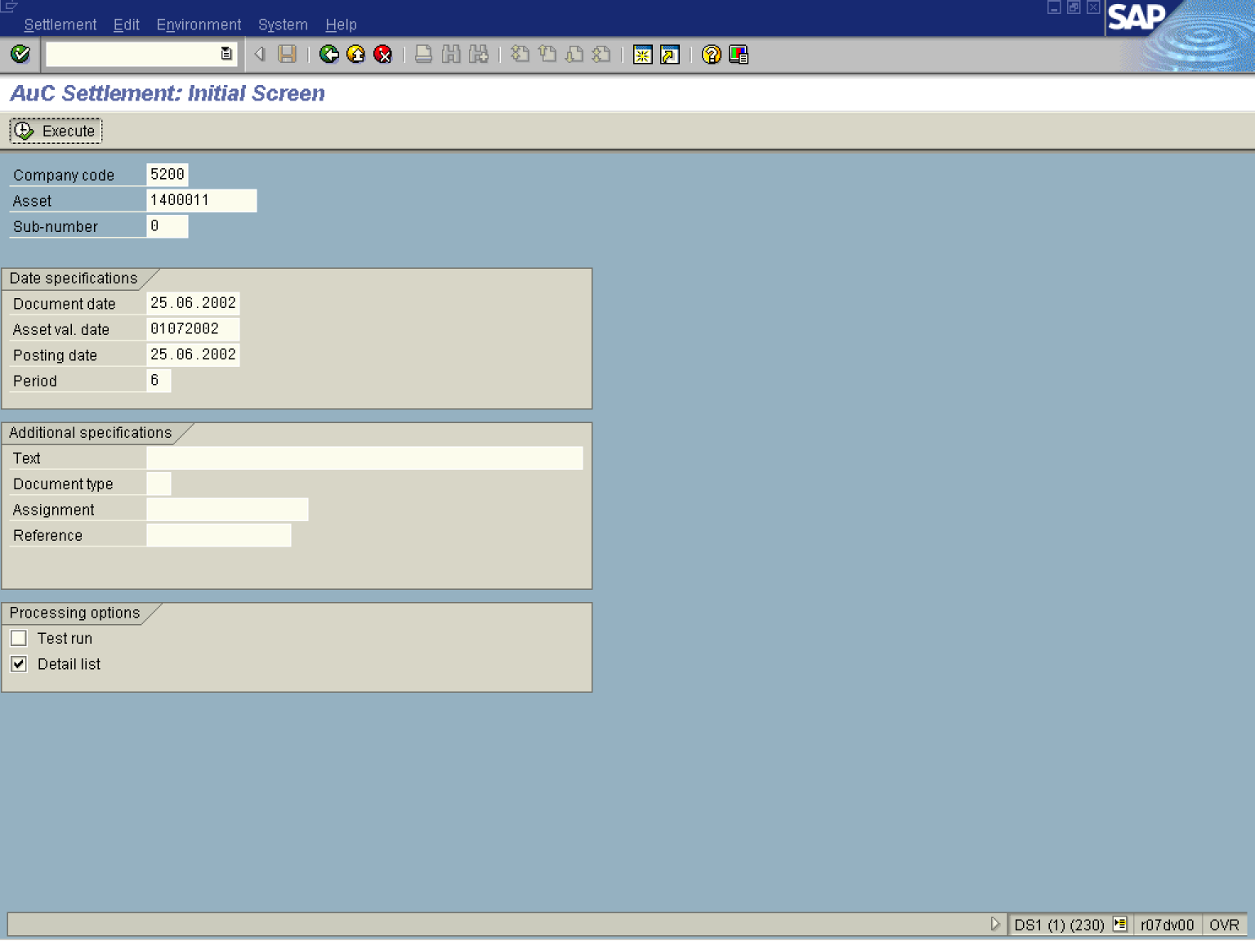
2. Update the following fields:

Field Name | Field Description | Values
Asset | This is the number which, together with the asset sub-number, identifies a fixed asset in Asset Accounting. | Example: 1400011
Document Date | Enter the date the original document was created. | Example: 25.06.2002
Asset val. date | Asset Value Date. This date is the date used on the asset master. | Example: 01072002
Posting date | Date which is used when entering the document in Financial Accounting or Controlling. | Example: 25.06.2002
Text | Description of the transaction | Example: June settlement
3. Click <checkbox> Test run .

Note: When the flag is active: the program is executed normally, all checks in the program are performed, their results are output in various forms (as single message, as a collection of messages, or as a log), but existing data are not changed.
When the flag is inactive: the program is executed normally. All data changes (change, delete, insert new data records) are made in the database (real run).
4. Click Execute .
Settlement of Asset u. Const: Receiver List

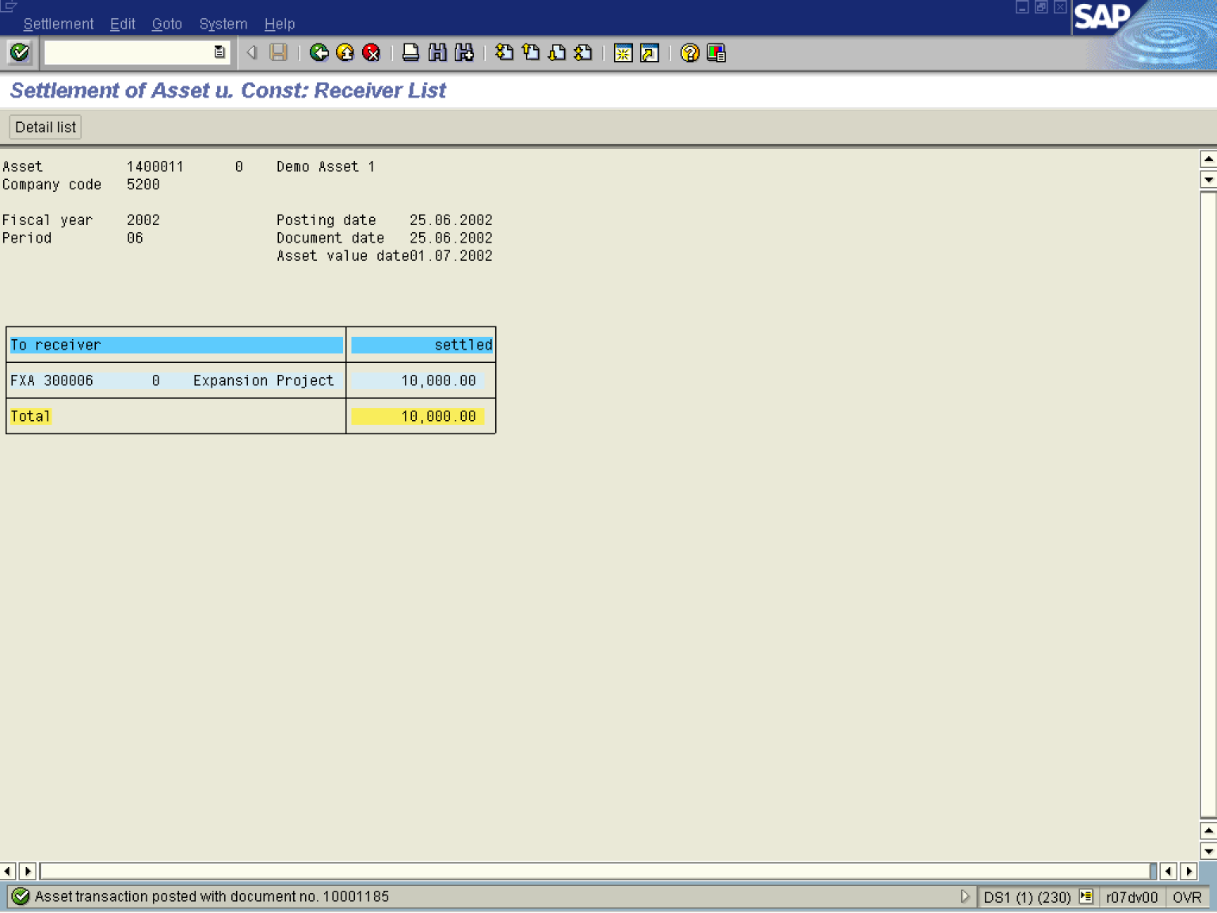

5. The message bar displays “Asset Transaction posted with document no. XXXXXX”

